Deployment Groups in Azure DevOps Tested on following AWS Image:

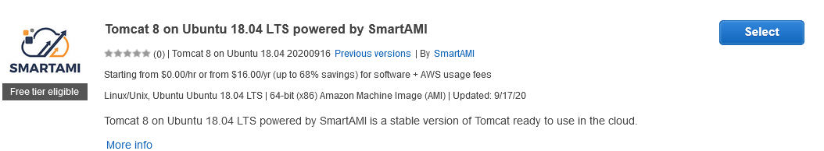

If we are planning to use the YAML Pipelines for the WAR deployment and if we need approvals, we need to create STANGING and PRODUCTION in the ENVIRONMENTS.

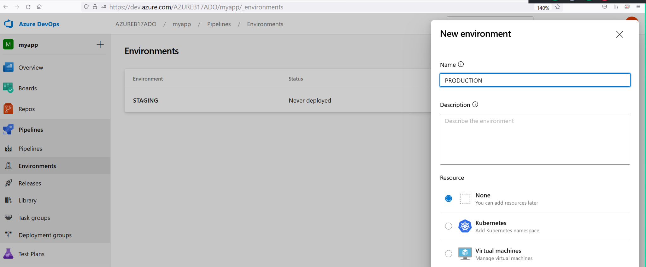

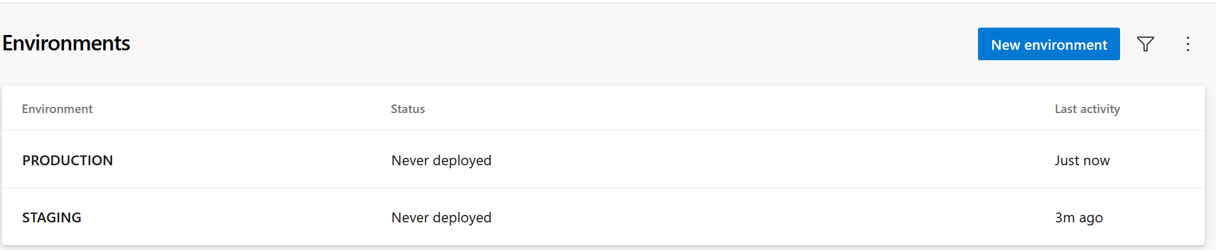

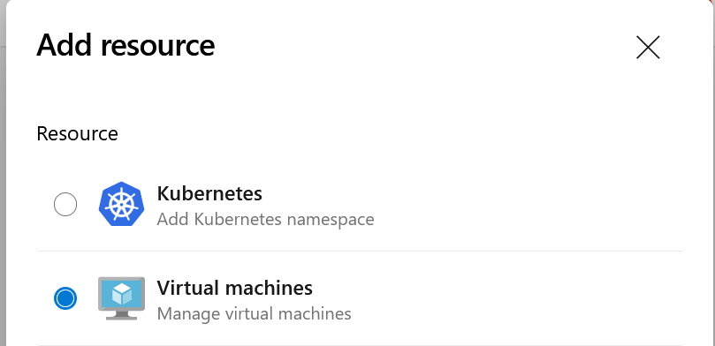

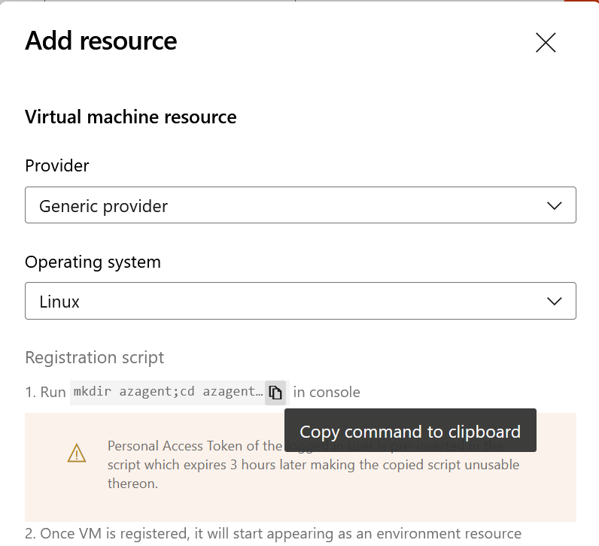

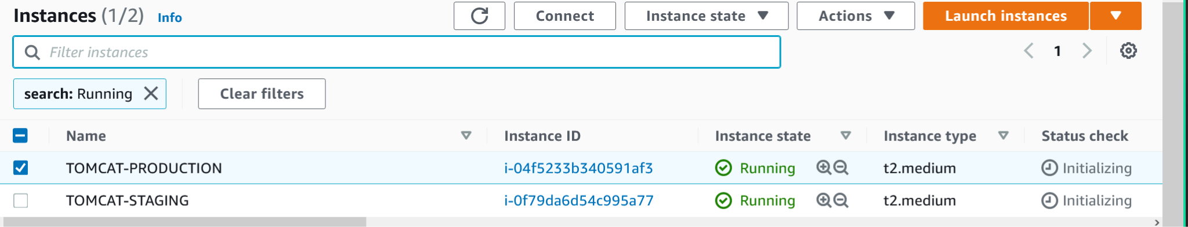

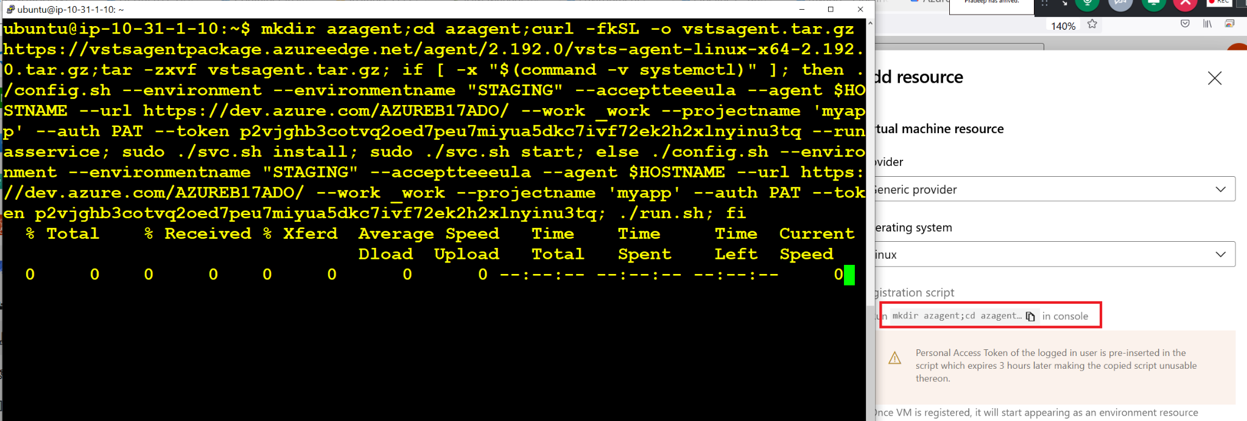

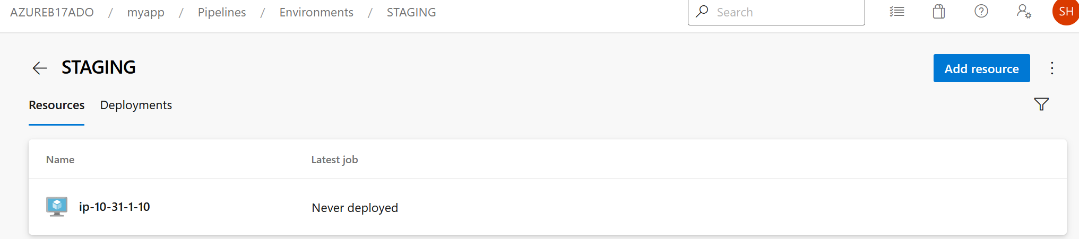

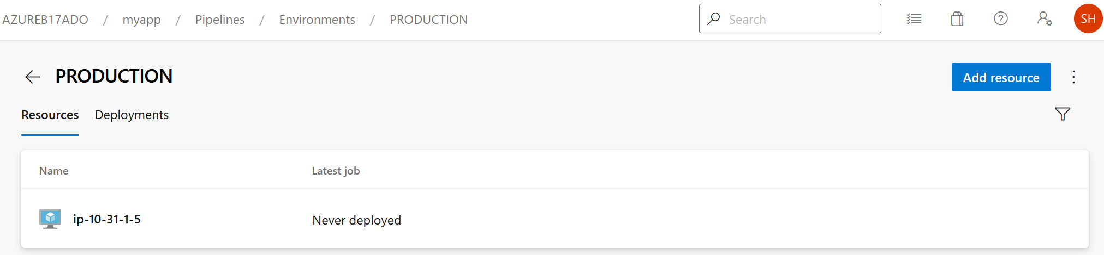

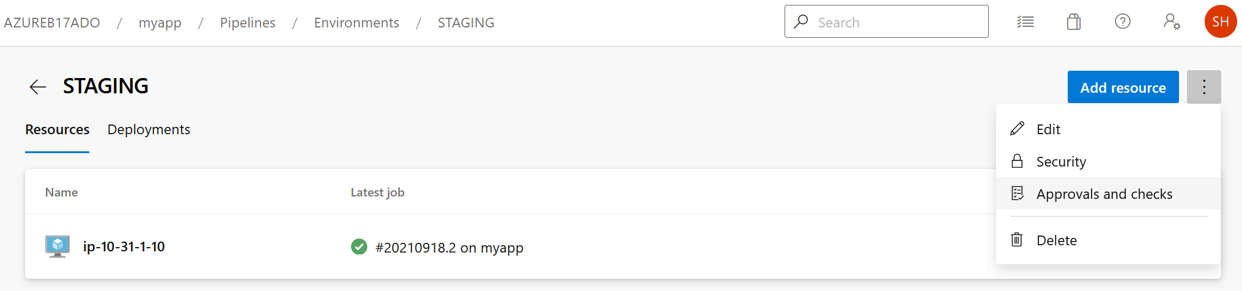

We can create Deployment Groups for Release Pipelines using the above Environments as shown below.

Initially below picture showing 2 Deployment Groups and 2 Available Pools.

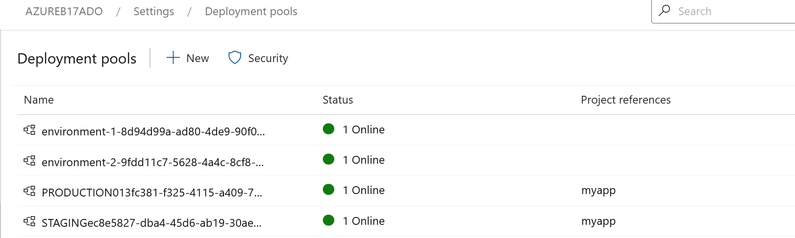

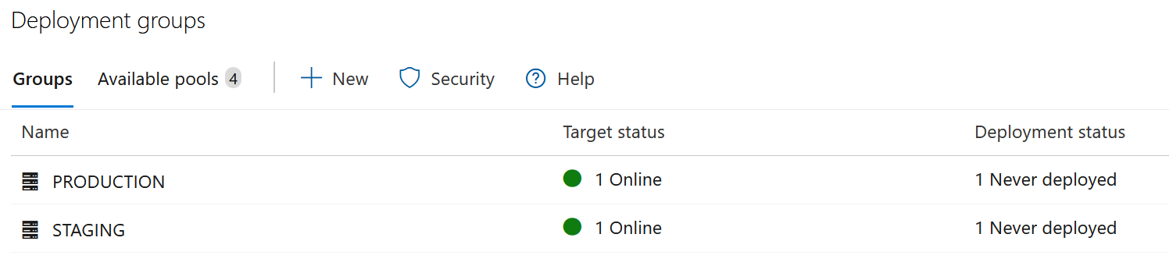

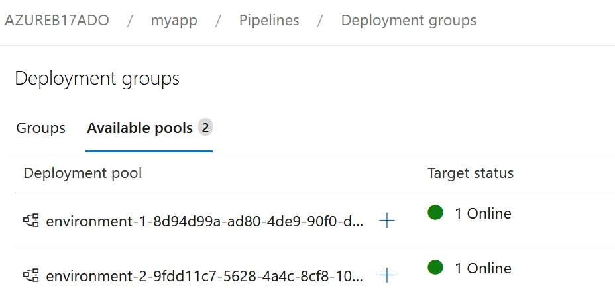

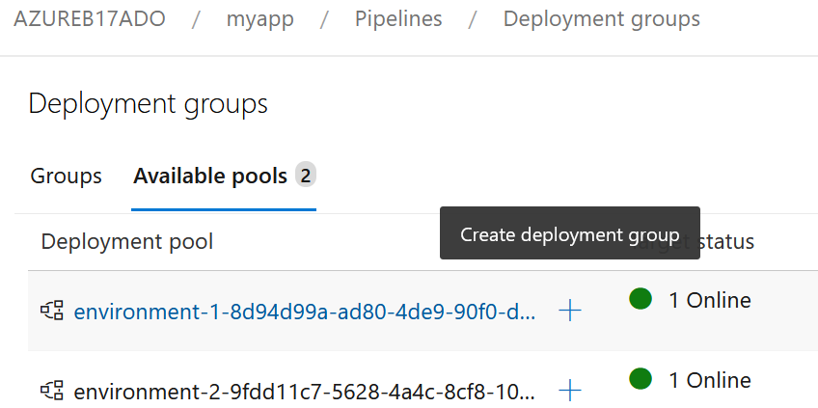

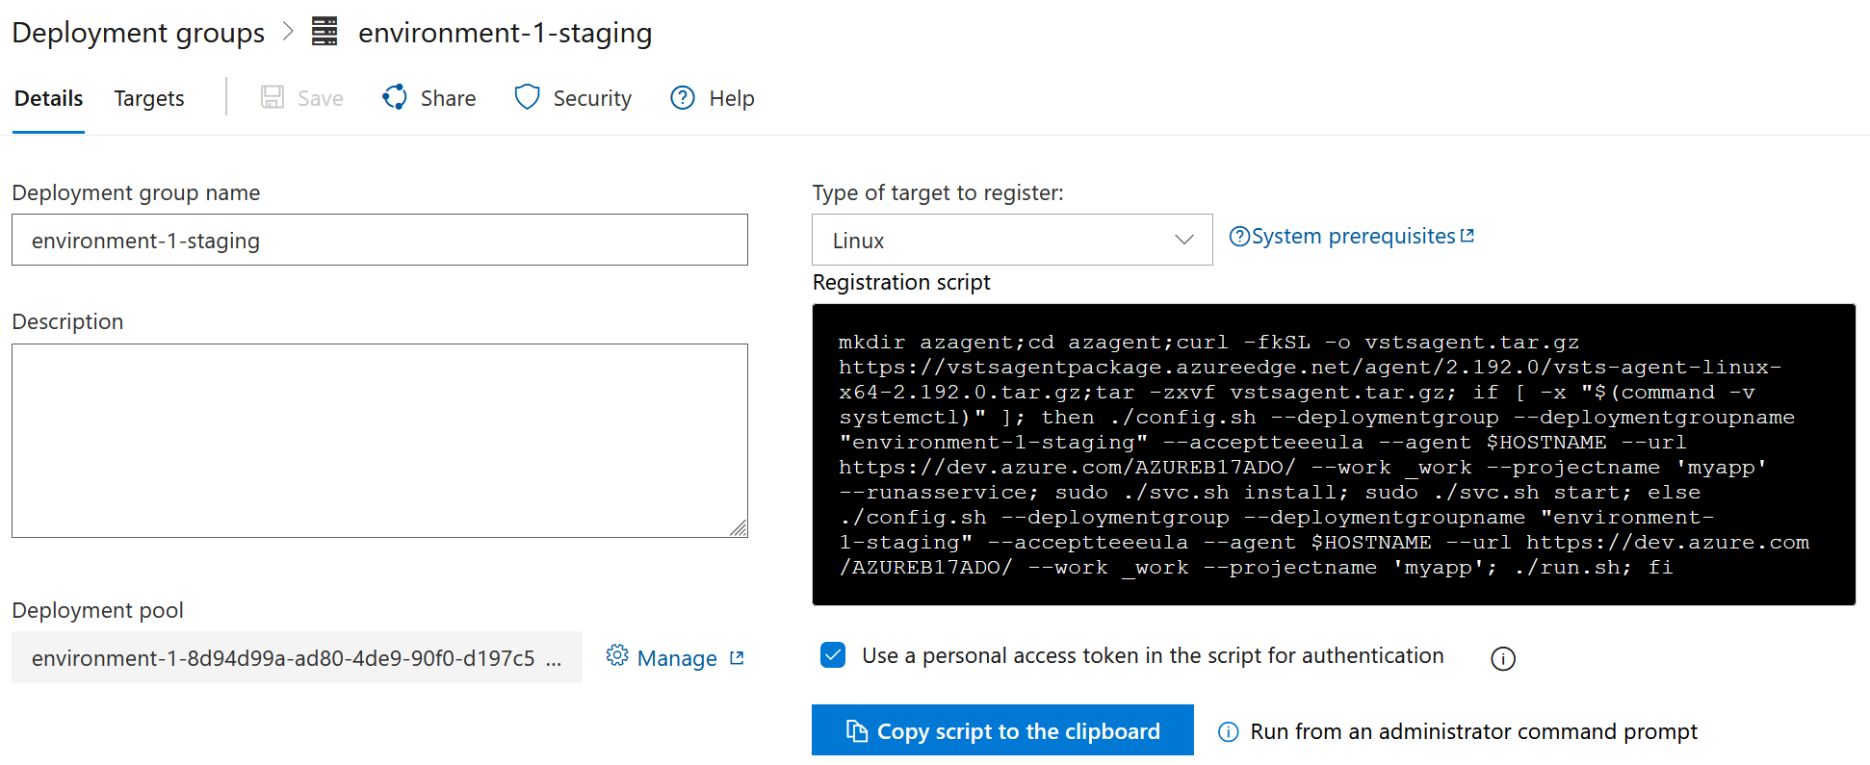

Based on the above we can use the YAML Environemnts as Deployment Groups by installing the agent which is not needed if you already have deployment groups.

sudo rm -rf /var/lib/tomcat8/webapps/mywebapp.war

cd /home/ubuntu/azagent/_work/r1/a/_<Your-Repo>

ls -al

sudo mv ROOT*.war ROOT.war

ls -al ROOT.war

sudo cp ROOT.war/ROOT*.war /var/lib/tomcat8/webapps/mywebapp.war

sudo rm -rf ROOT.war

<https://docs.microsoft.com/en-us/azure/devops/pipelines/process/deployment-jobs?view=azure-devops>

<https://stackoverflow.com/questions/58954243/yaml-iis-web-deploy-deployment-group>

